A Project Report On

**“Easy Japanese ”**

Submitted To

**Savitribai Phule Pune University**

In partial fulfilment of the degree of

**Bachelor of Business Administration - Computer Application**



By

**Unnati Gude 14407**

**Diksha Kadbe 14433**

BBA-CA

(Semester IV)

Under the guidance of

**Mrs. Padma Nene**

Research Guide

MES Garware College of Commerce, Karve Road, Pune 411004 (2021-2022)



**Maharashtra Education Society’s GARWARE COLLEGE OF COMMERCE Karve Road, Deccan Gymkhana,**

**Pune41104**

**CERTIFICATE**

This is to certify that --------------------------------------- has successfully completed the Project entitled “Easy Japanese” and has submitted the same to the satisfaction during the academic year 2021 – 2022 towards partial fulfilment of the degree ‘Bachelor of Business Administration -Computer Application’ of Savitribai Phule University of Pune.

(PROJECT GUIDE) (BBA-CA IN CHARGE) (PRINCIPAL)

(INTERNAL EXAMINER) (EXTERNAL EXAMINER)

**Index**

1. Introduction
2. Objectives
3. Hardware and Software
4. Scope
5. System Analysis
6. System Design
7. Layout of the Website
8. Limitations
9. Bibliography

**Introduction**

As the name of our website says, our project is about learning Japanese language easily.

Introducing basics of Japanese language so that it will be easy for beginners to cope up with Japanese studies.

And motivating to carry on the studies by making it fun and simple.

**Objectives**

1. Introducing basics of Japanese language making it fun and simple.
2. Providing information about certifications of Japanese language.
3. Providing helpful free study resources for Japanese language studies.
4. A short quiz for testing your gained knowledge.
5. To help you get going with Japanese studies.

**Hardware and Software**

Minimum Hardware Requirements

Memory: 1.00GB RAM or More

Additional Devices- USB Drive and Printer

Minimum Software Requirements

OS - Windows 10

Front End - HTML,CSS,JAVASCRIPT,ANGULARJS

Browser – Google Chrome

**Scope**

Our website not only gives a short and basic idea about the Japanese Language for the beginners but also provides useful information to the students who are looking for extra study materials.

So we have introduced various websites, online resources available and useful for studying Japanese.

By making good use of the internet for studying new language and motivating learners who are looking for fun ways to study Japanese.

**System Analysis**

Many beginners struggle to find how to start with language learning ,so to help them solve this problem we have created this website.

Those learners who are already studying the language but want to find out appropriate materials for study purpose as well as for extra learning our website solves that problem.

**System Design**

Entity Relationship Diagram

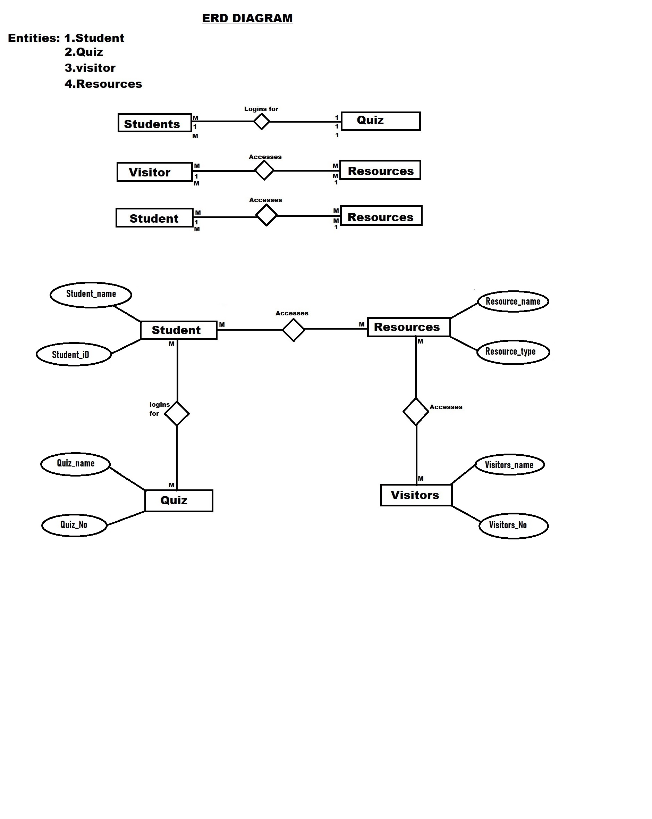

Data Flow Diagram

* Context level Diagram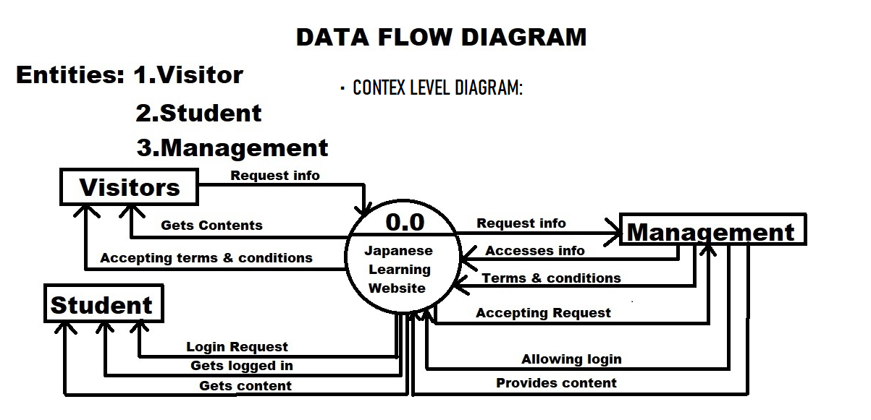
* 1st Level DFD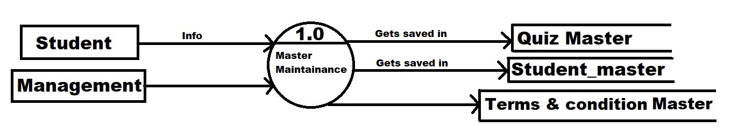
* 2nd Level DFD

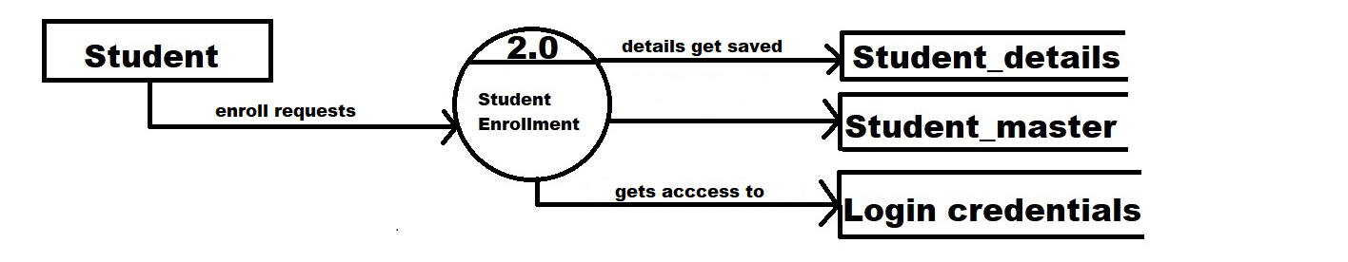

* 3rd Level DFD

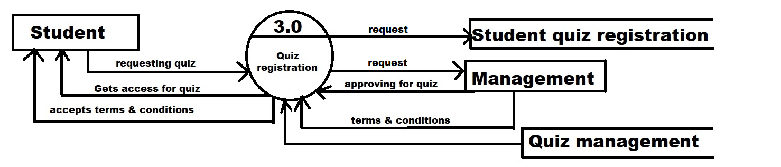

* 4th Level DFD

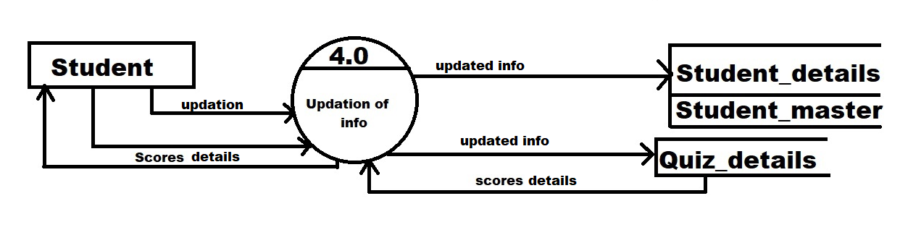

* 5th Level DFD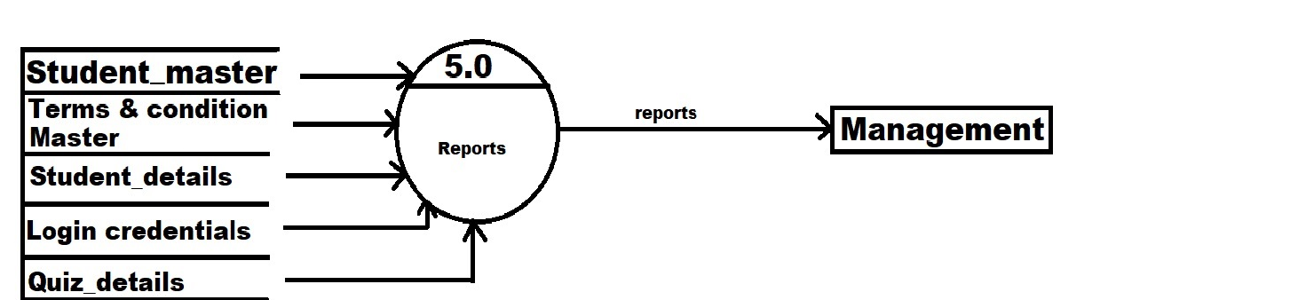

**Layout of the Website**

Homepage

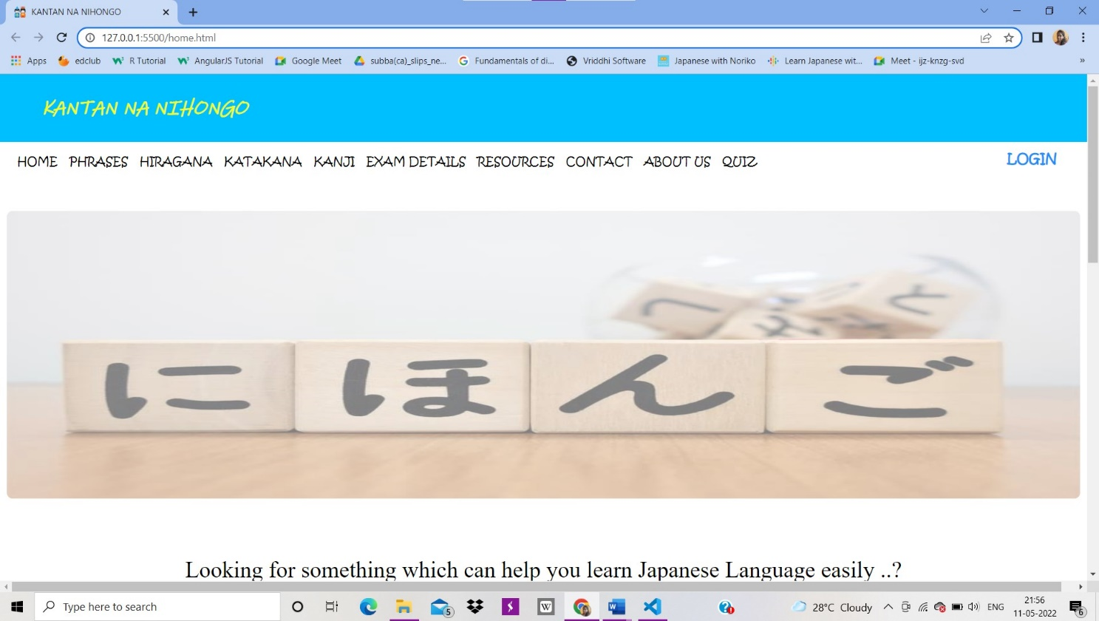

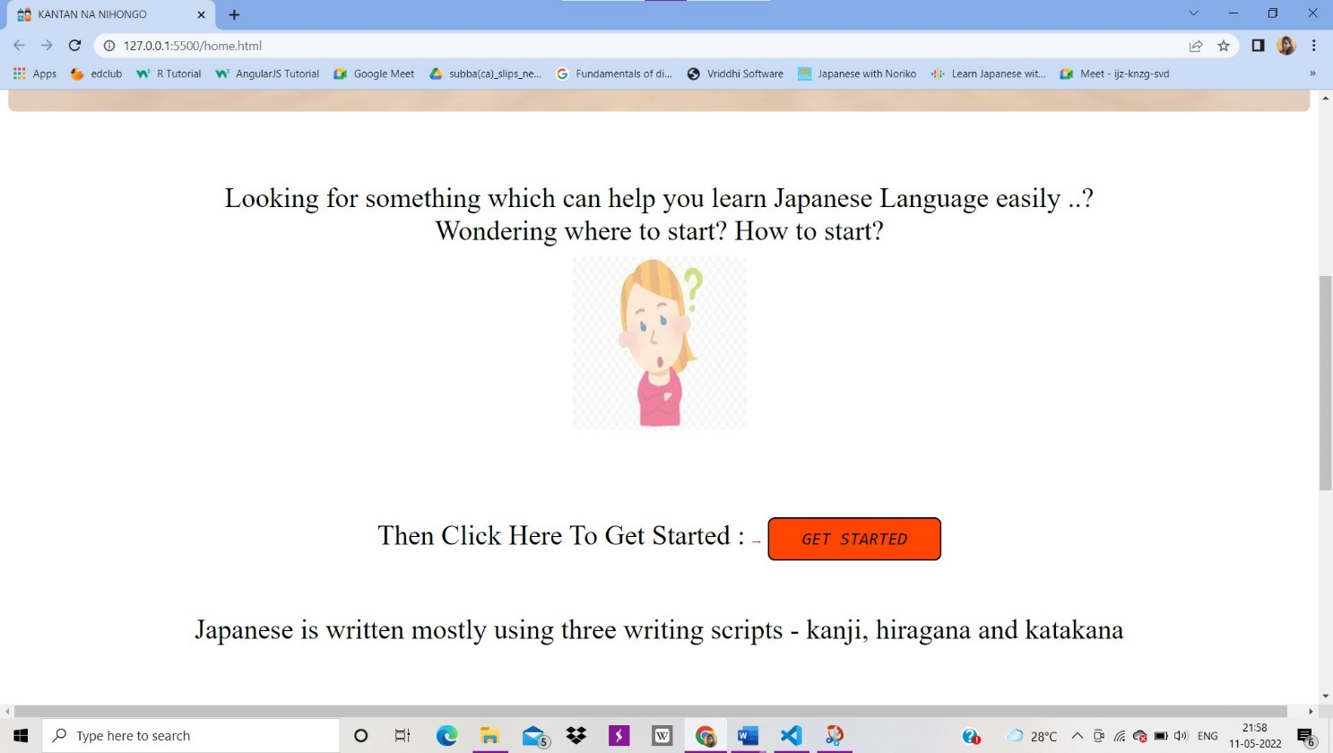

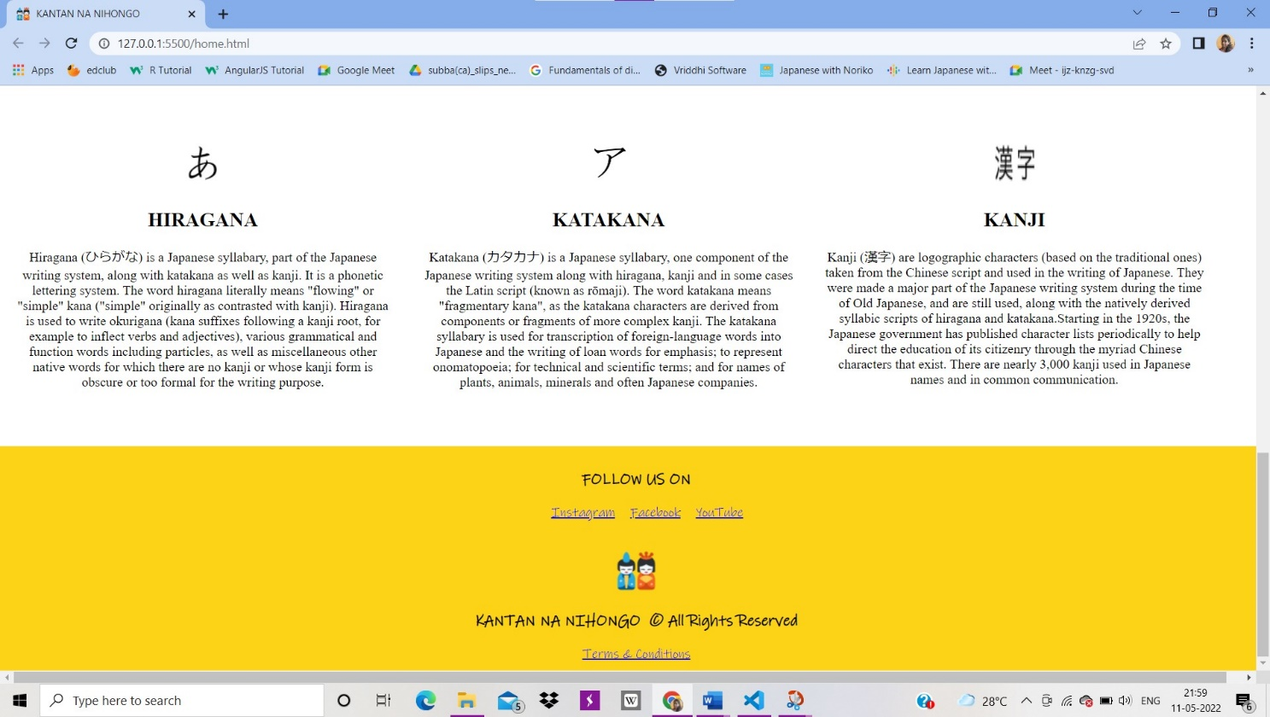

Phrases

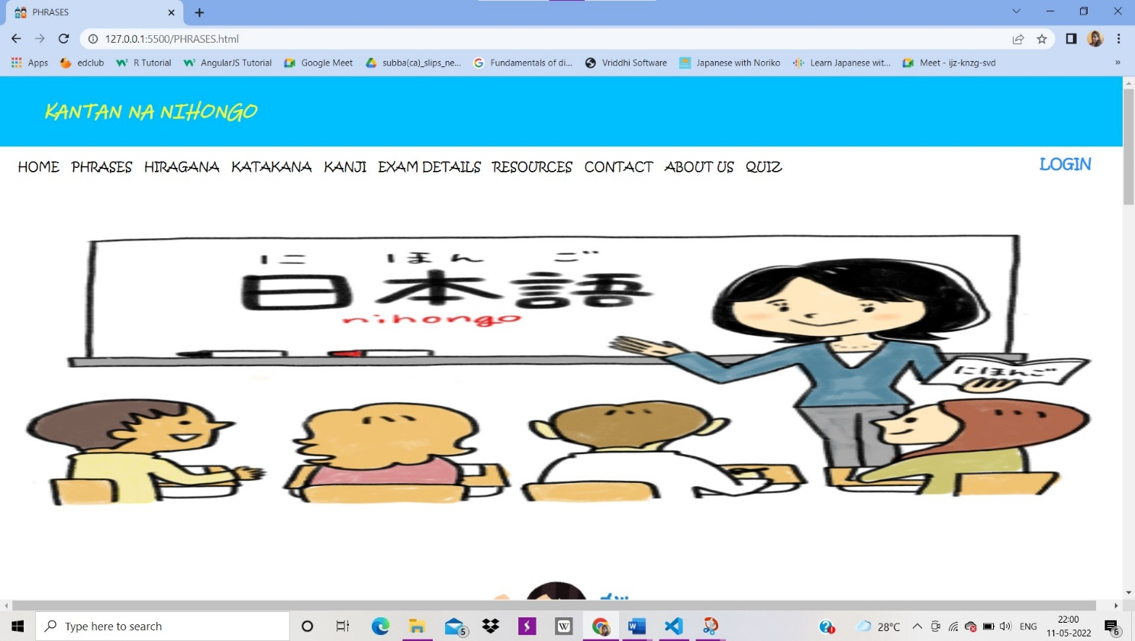

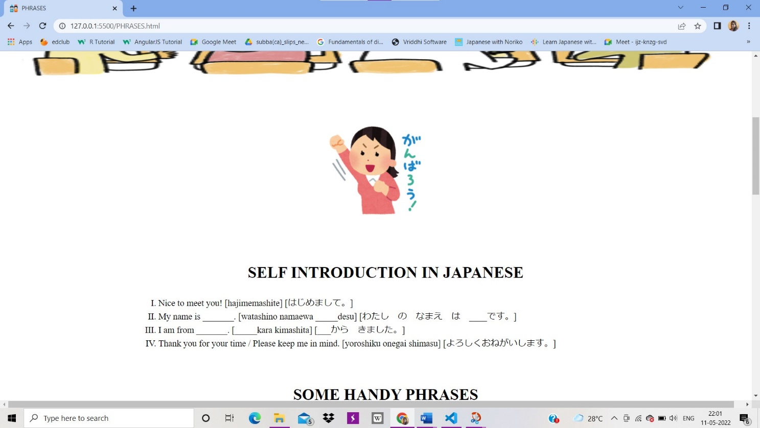

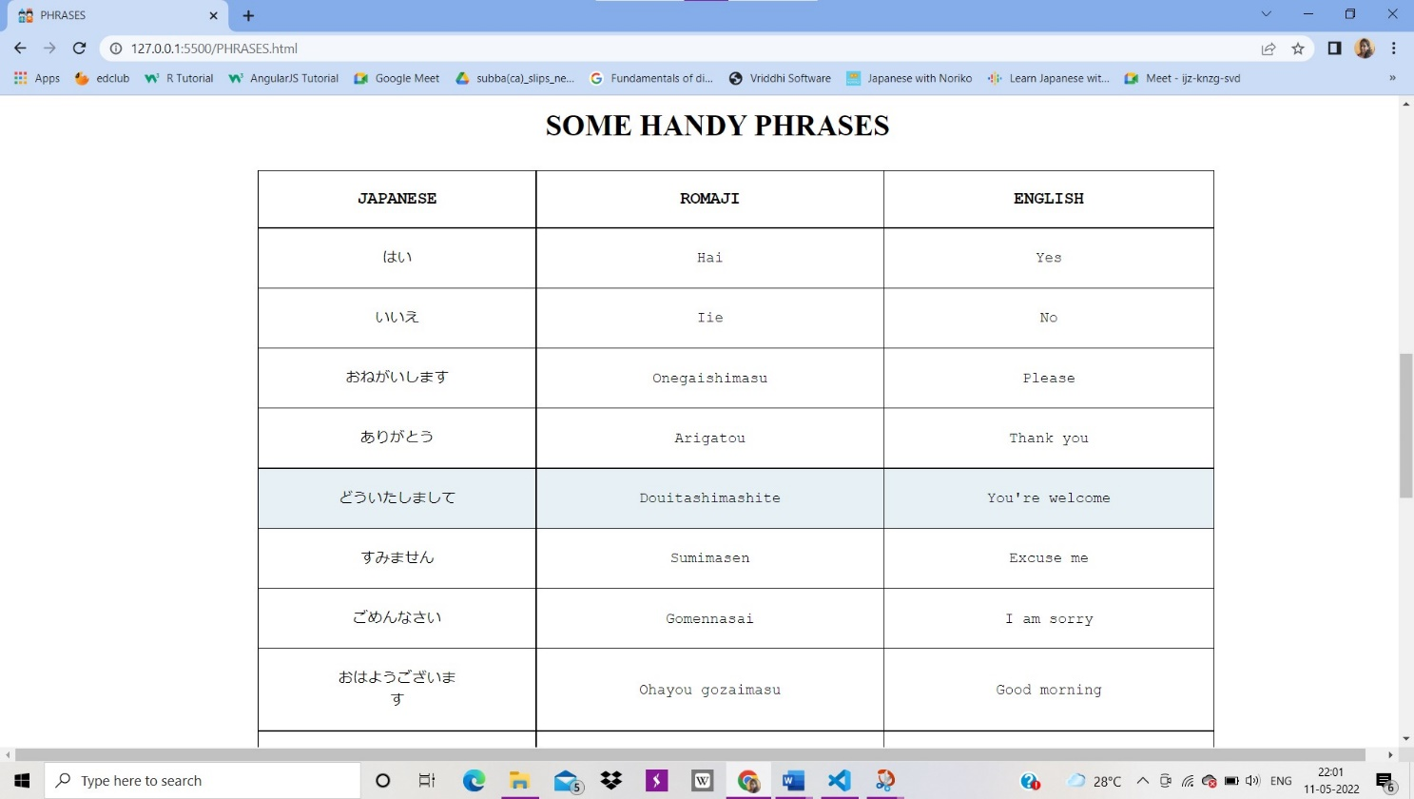

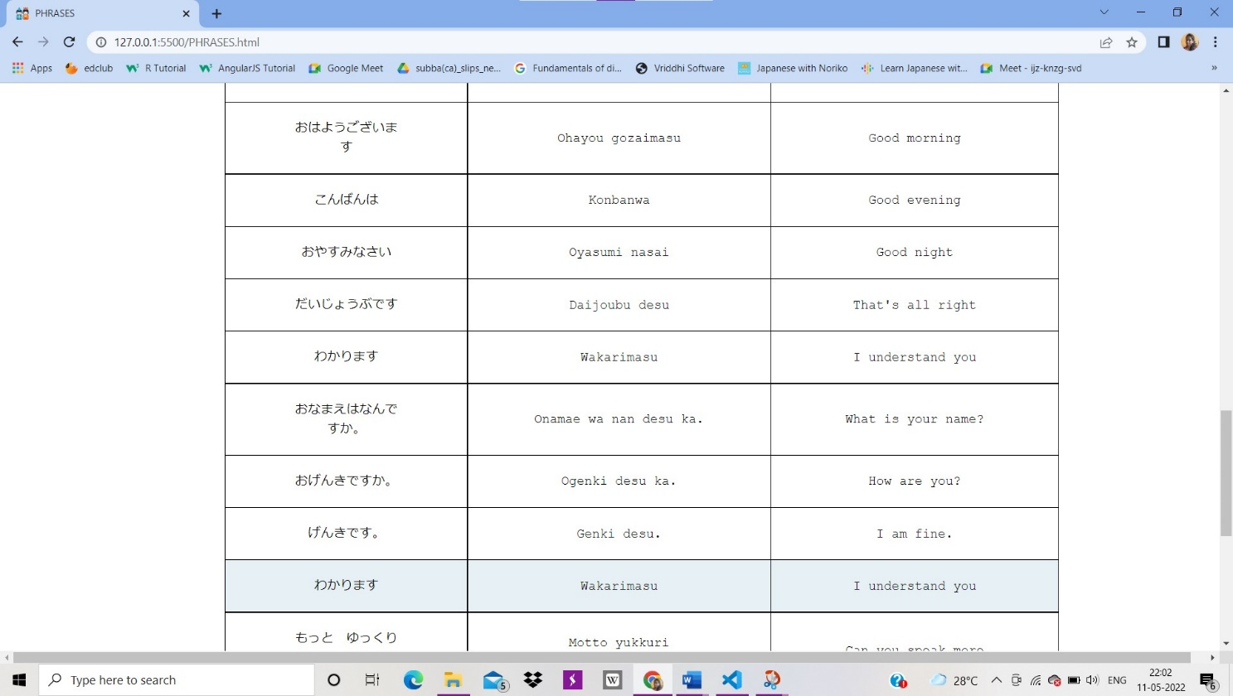

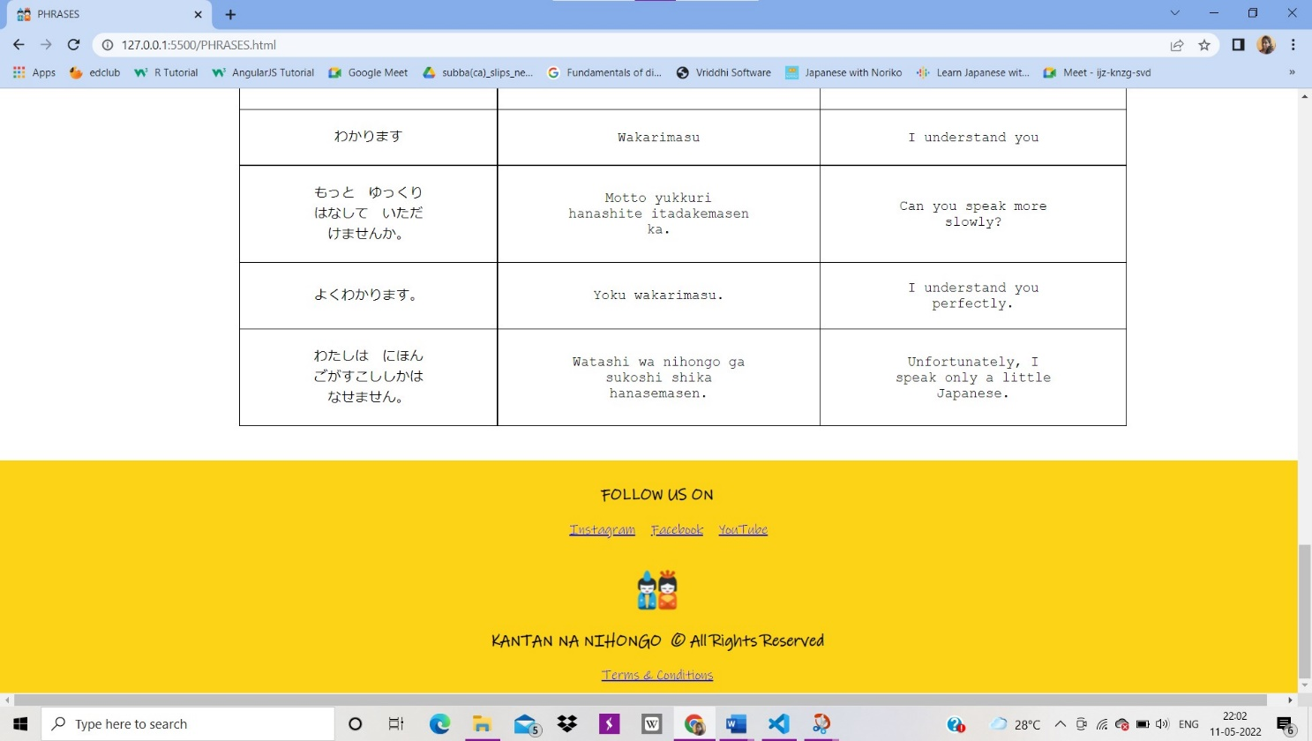

Hiragana

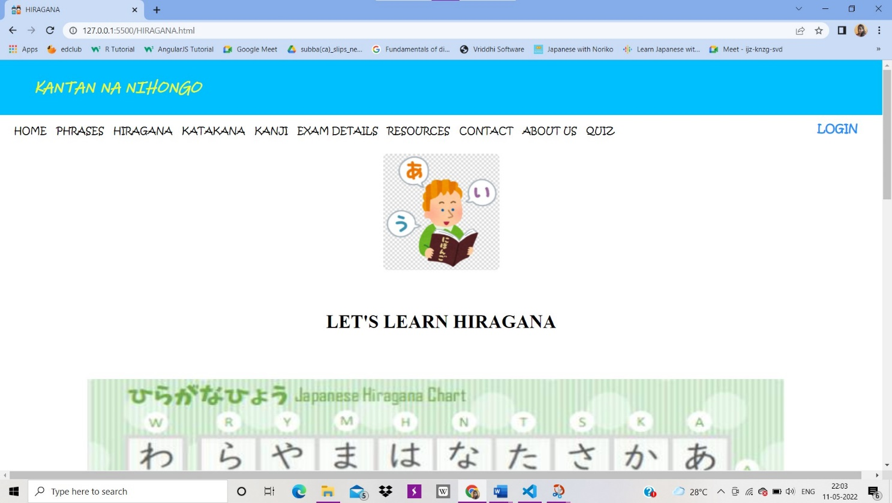

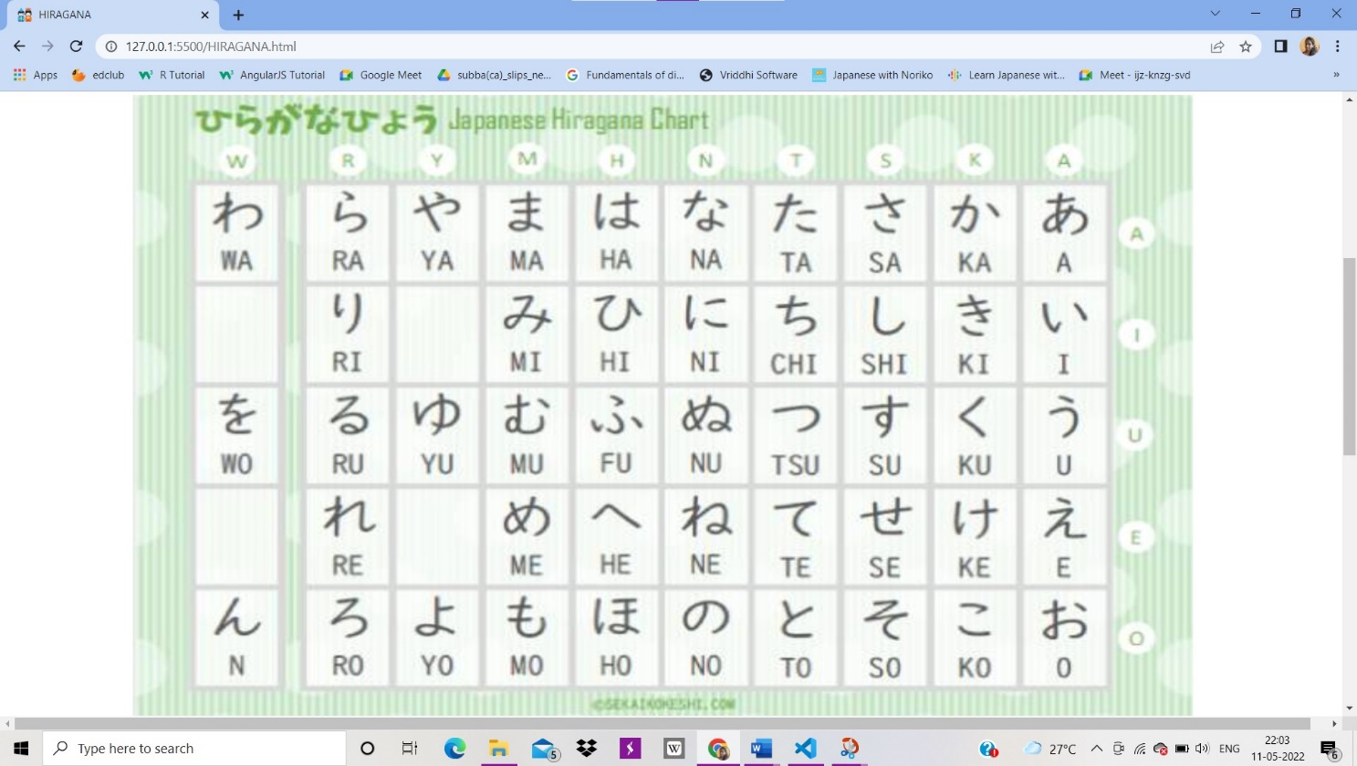

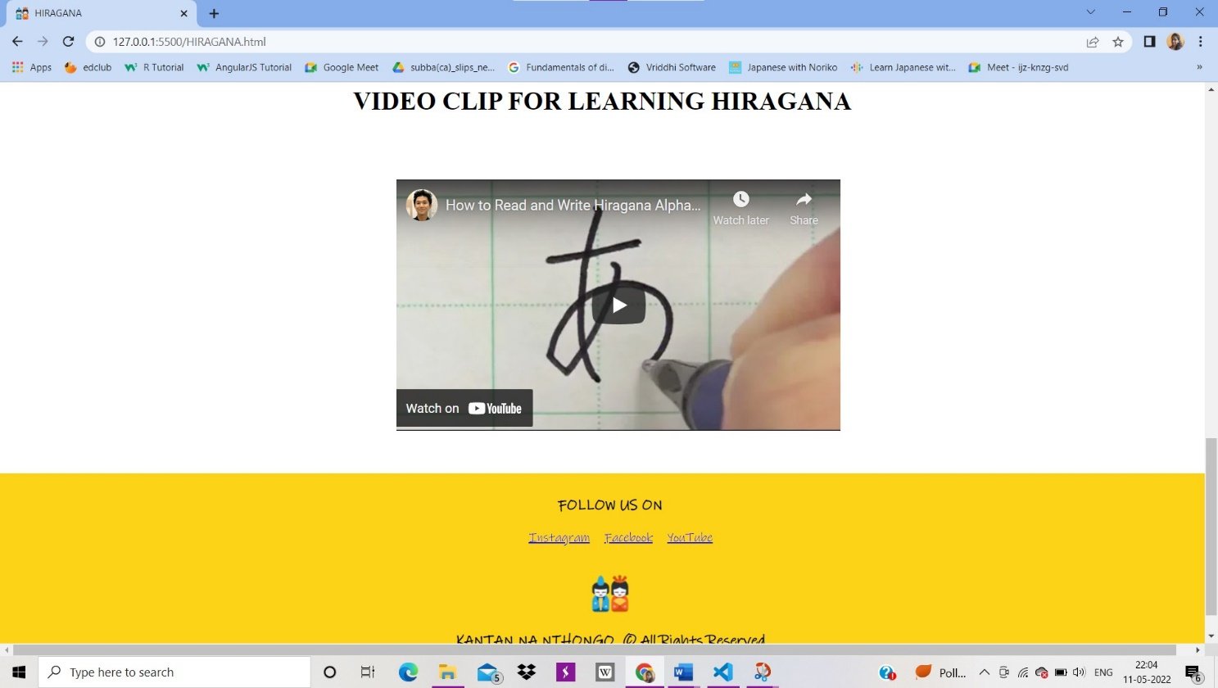

Katakana

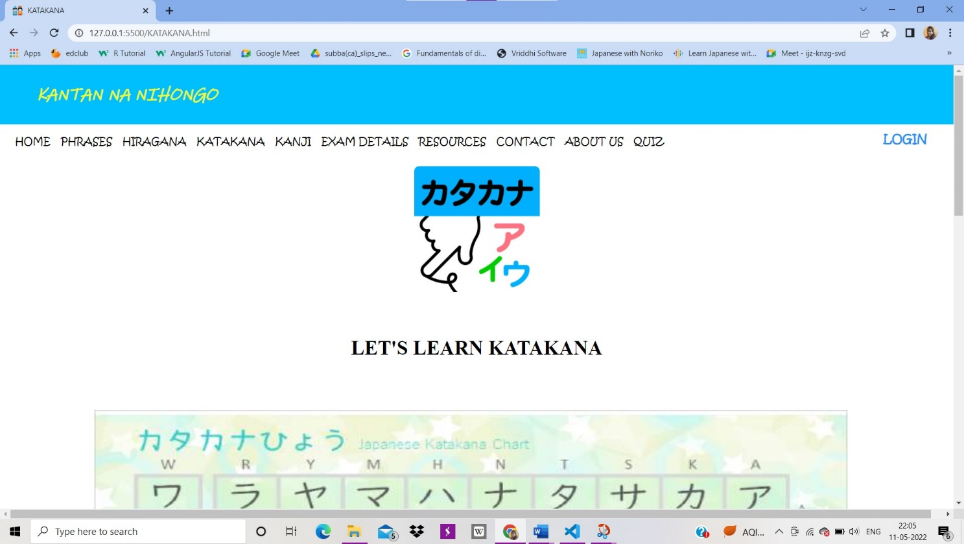

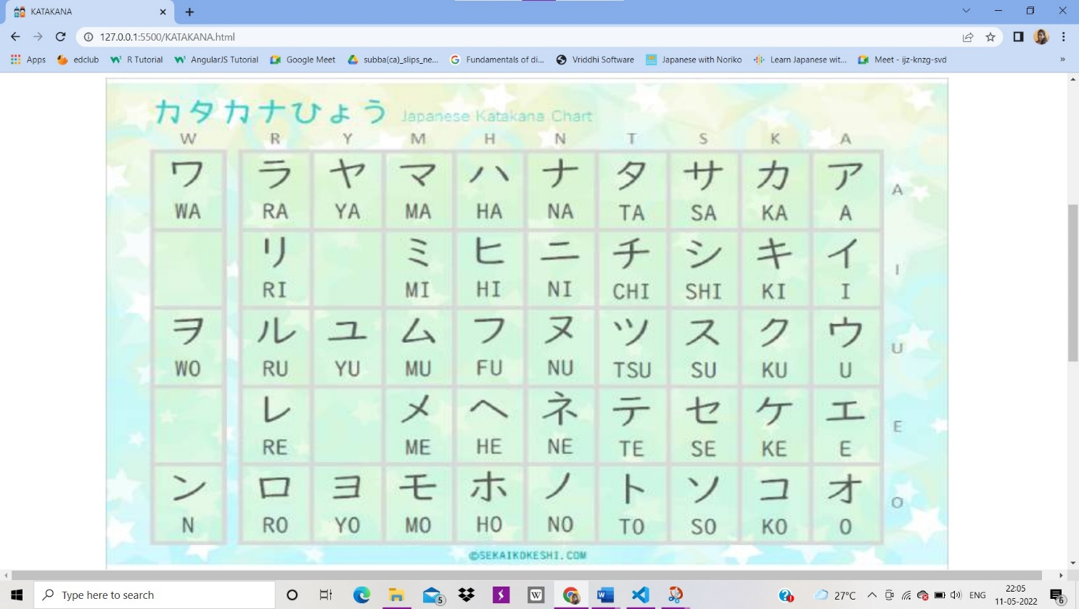

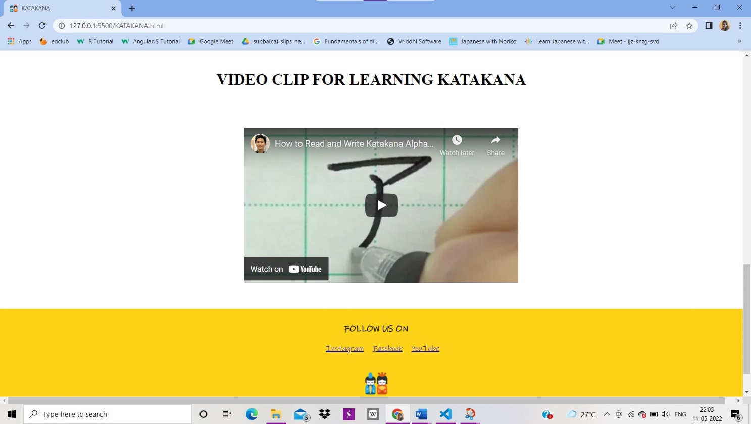

Kanji

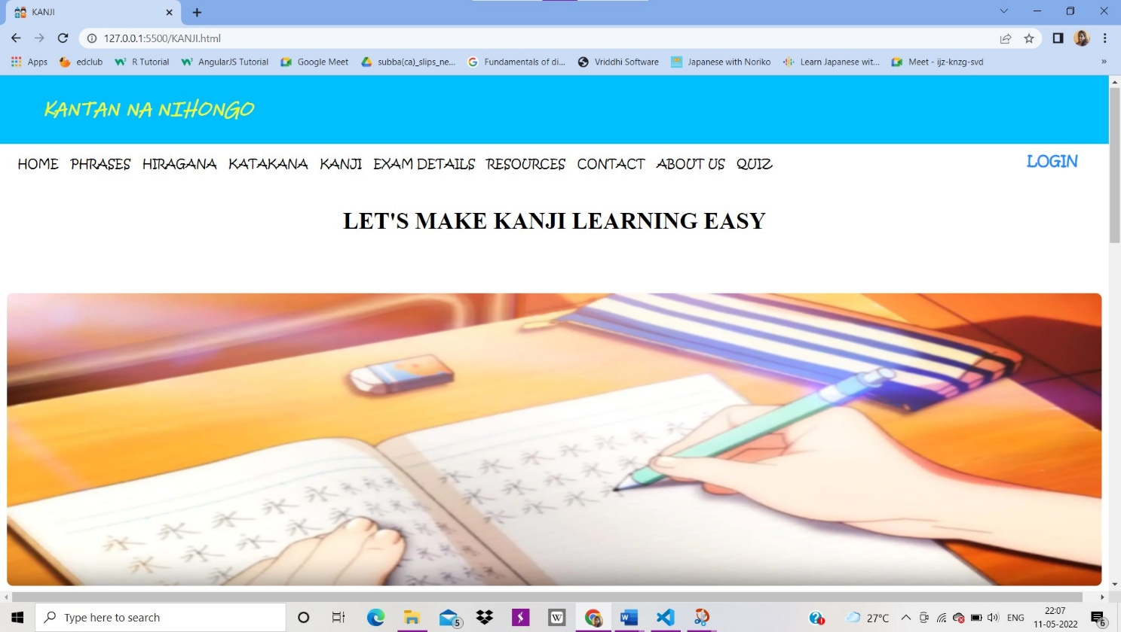

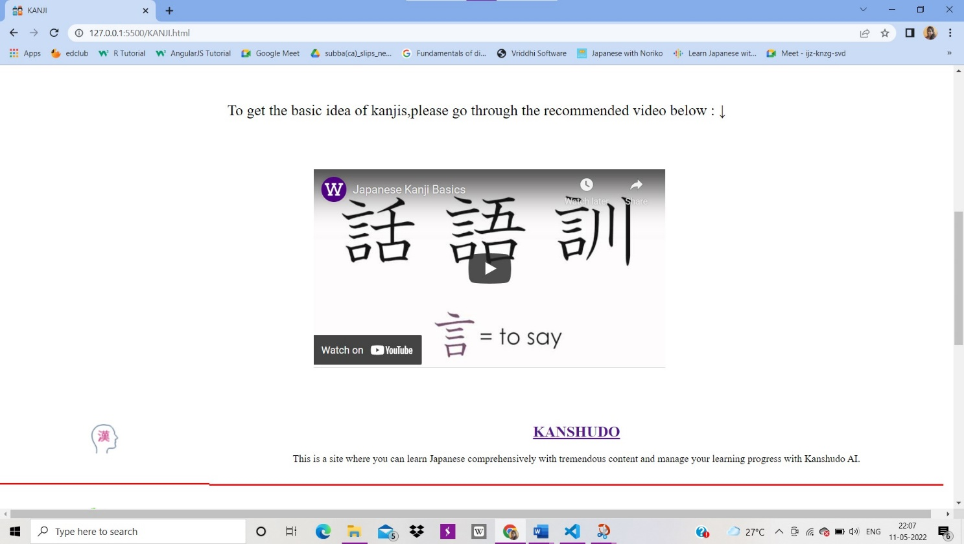

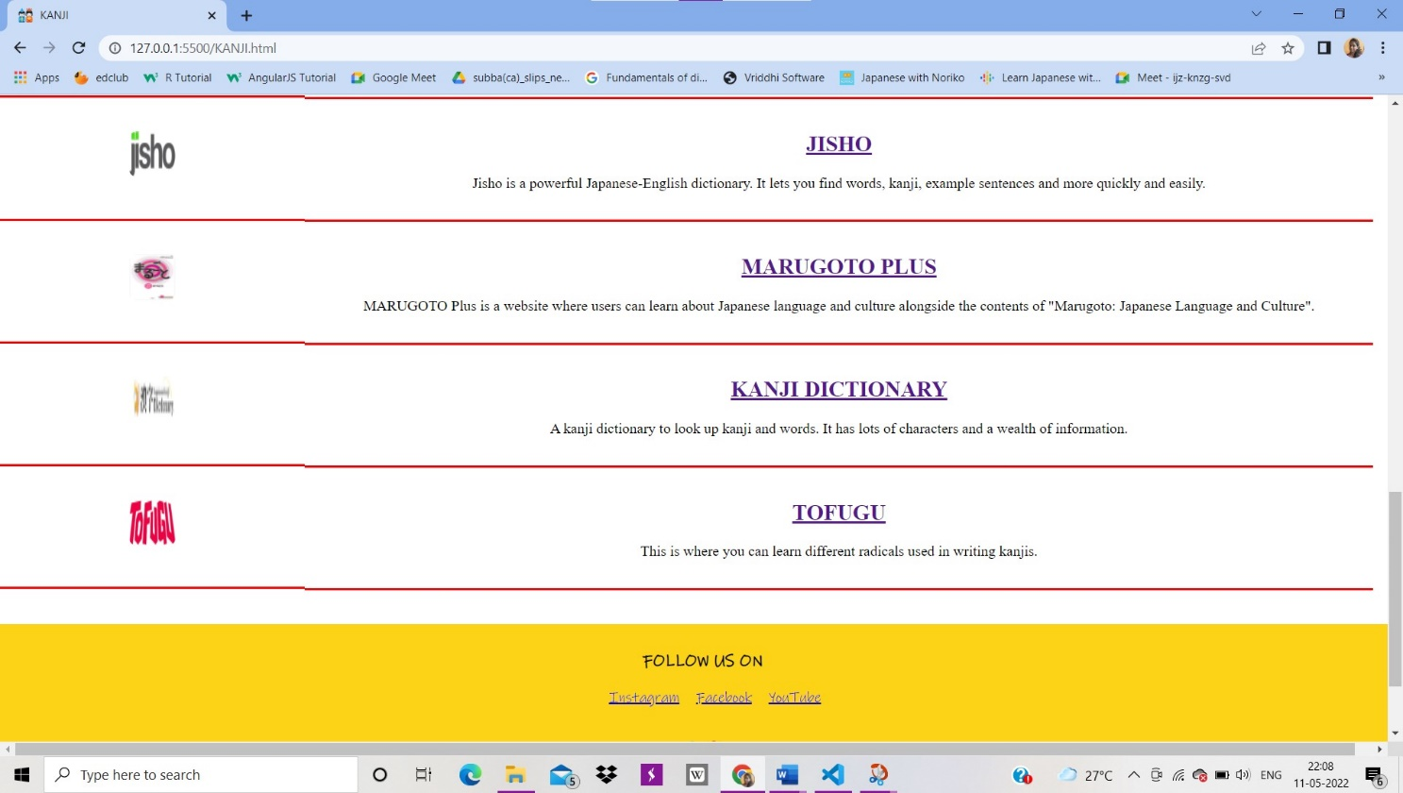

Exam Details

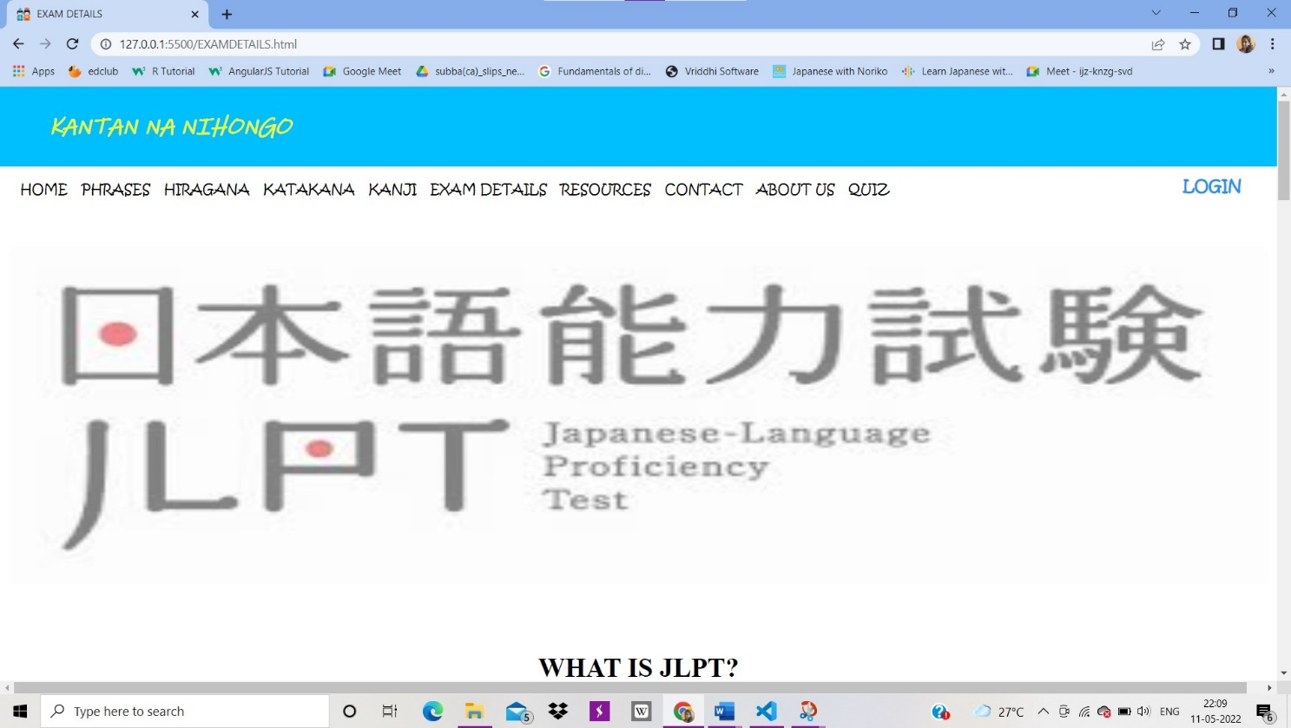

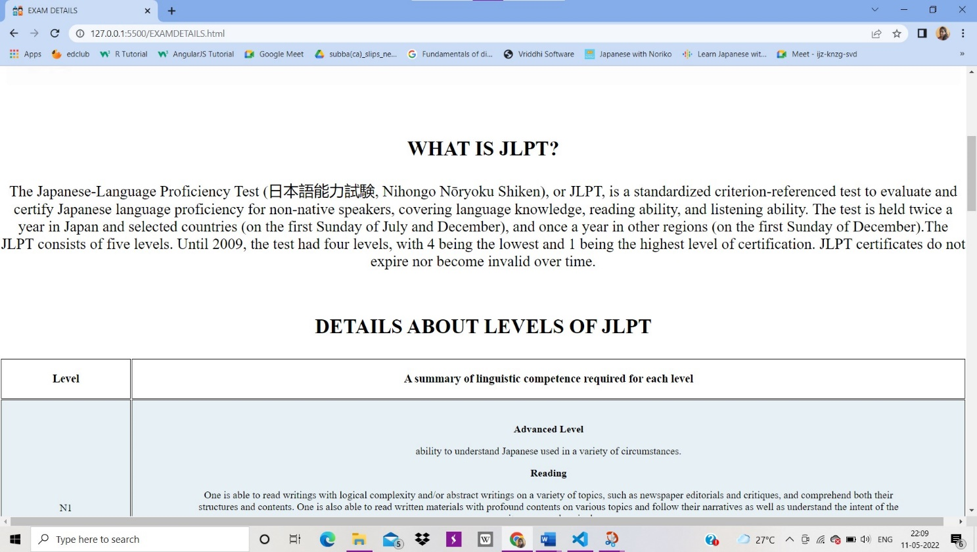

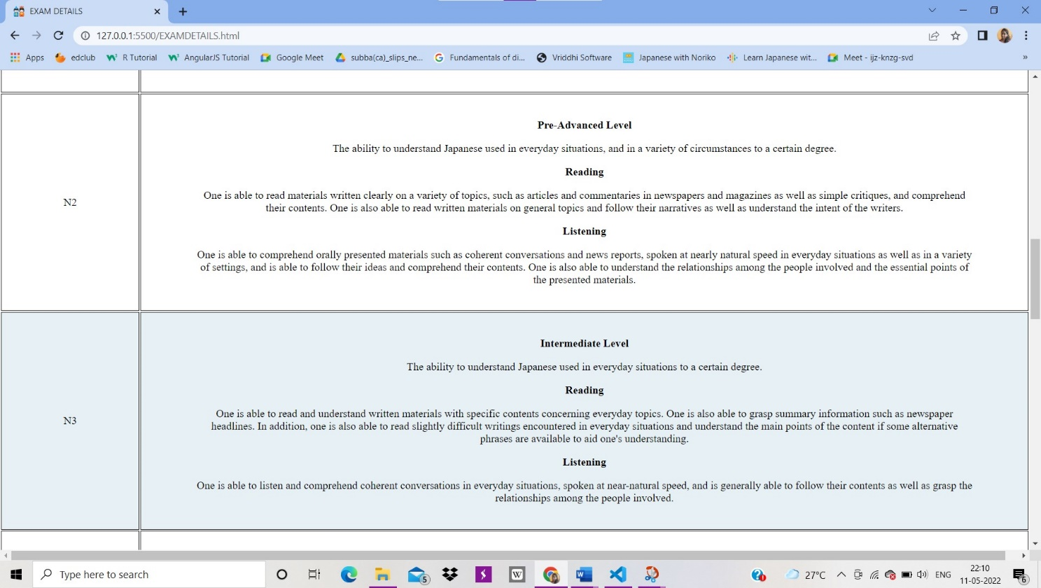

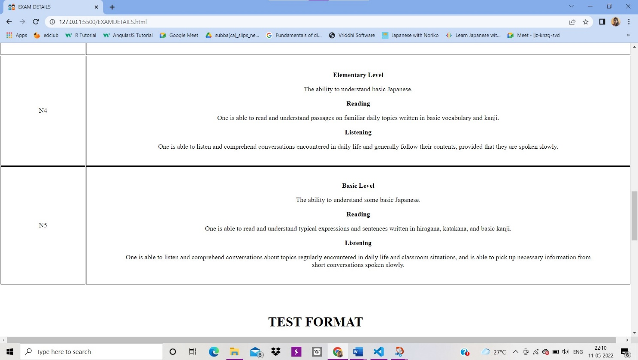

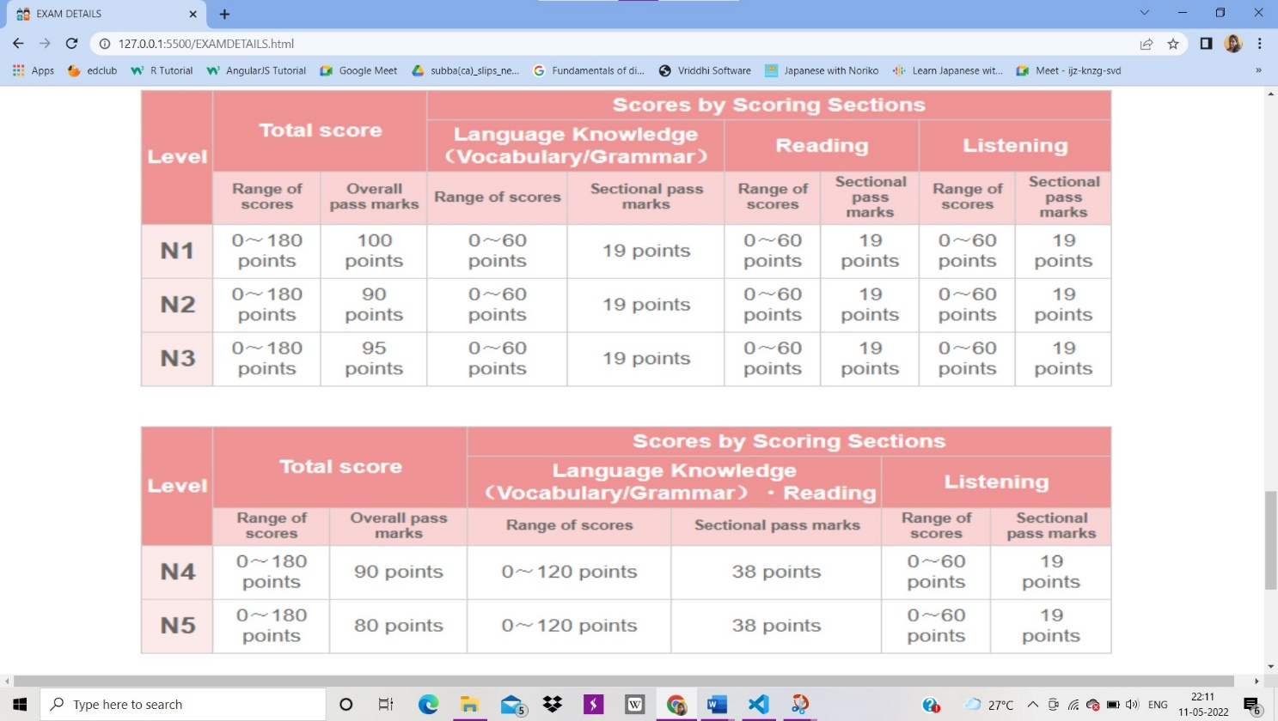

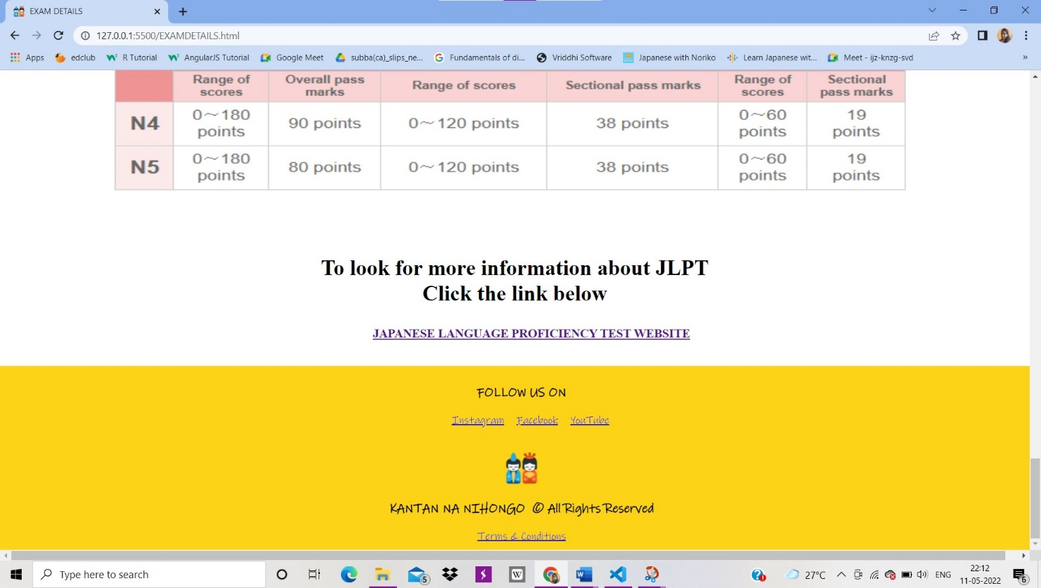

Resources

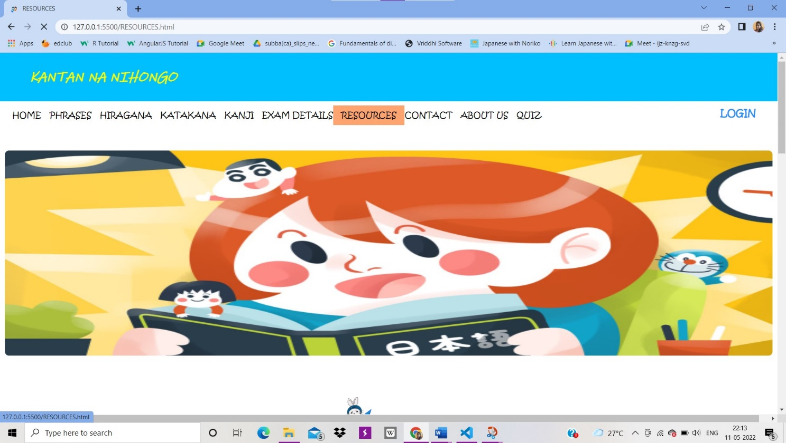

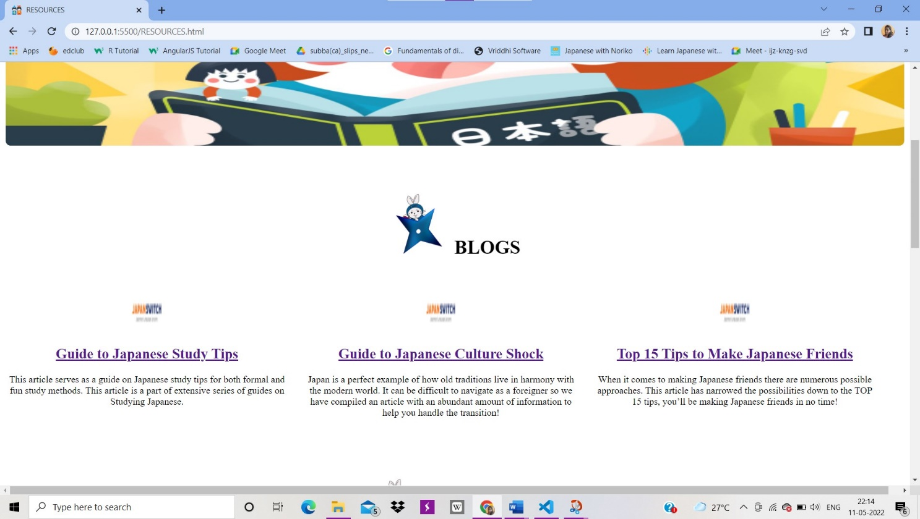

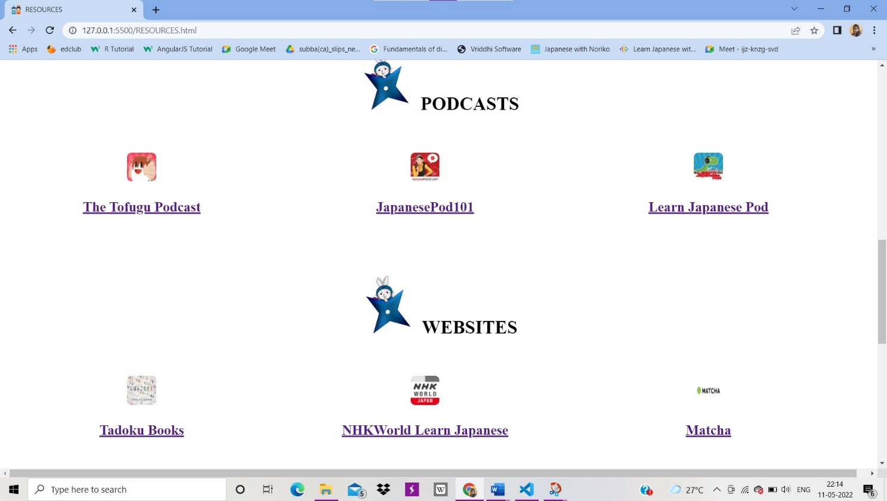

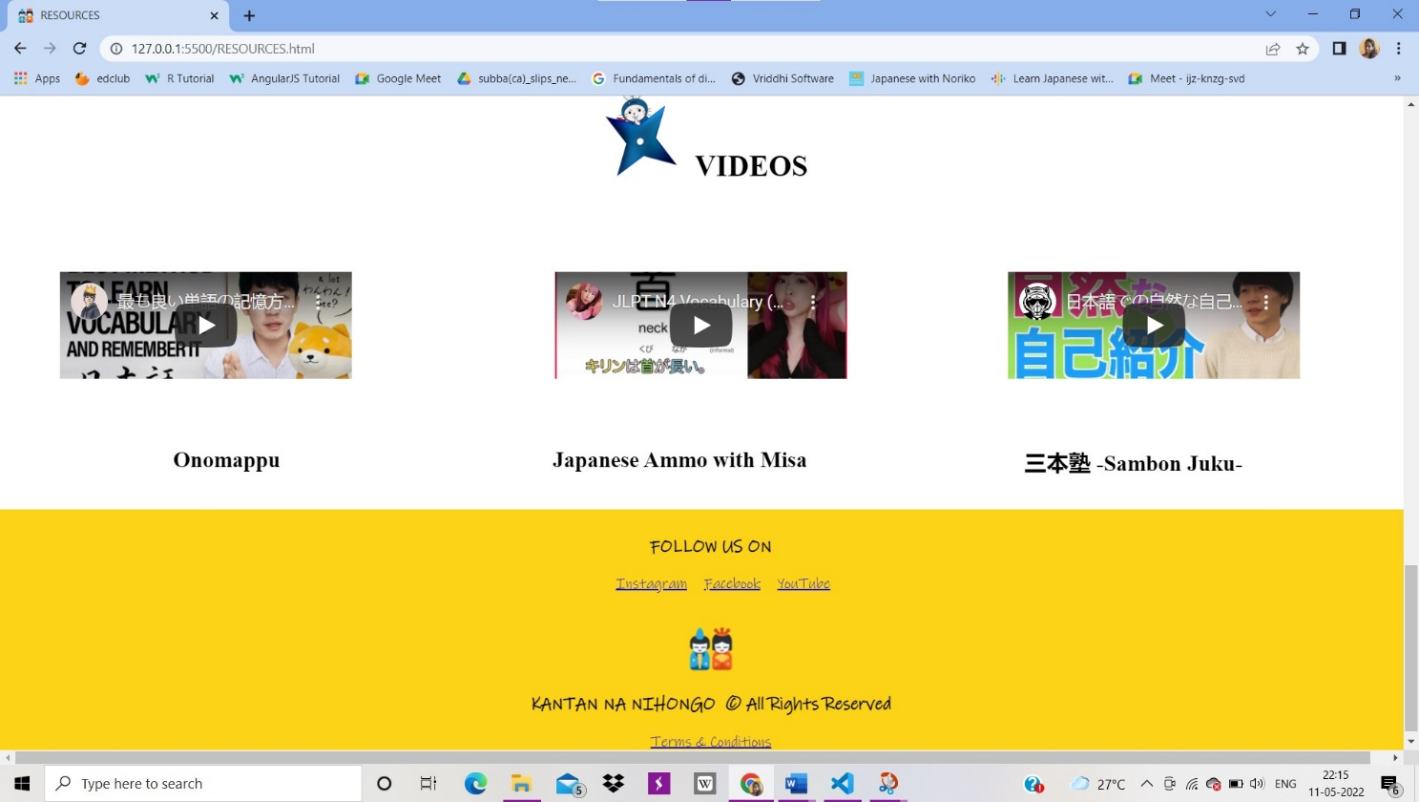

Contact

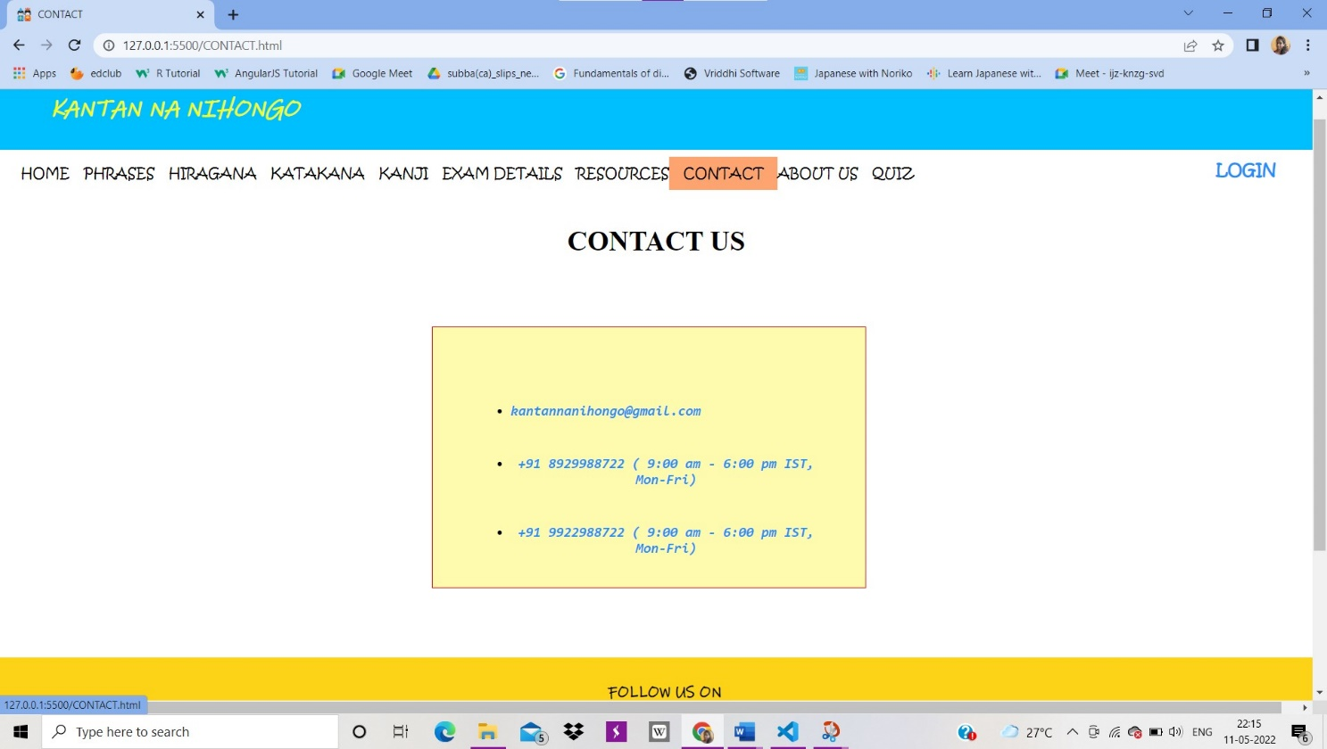

About Us

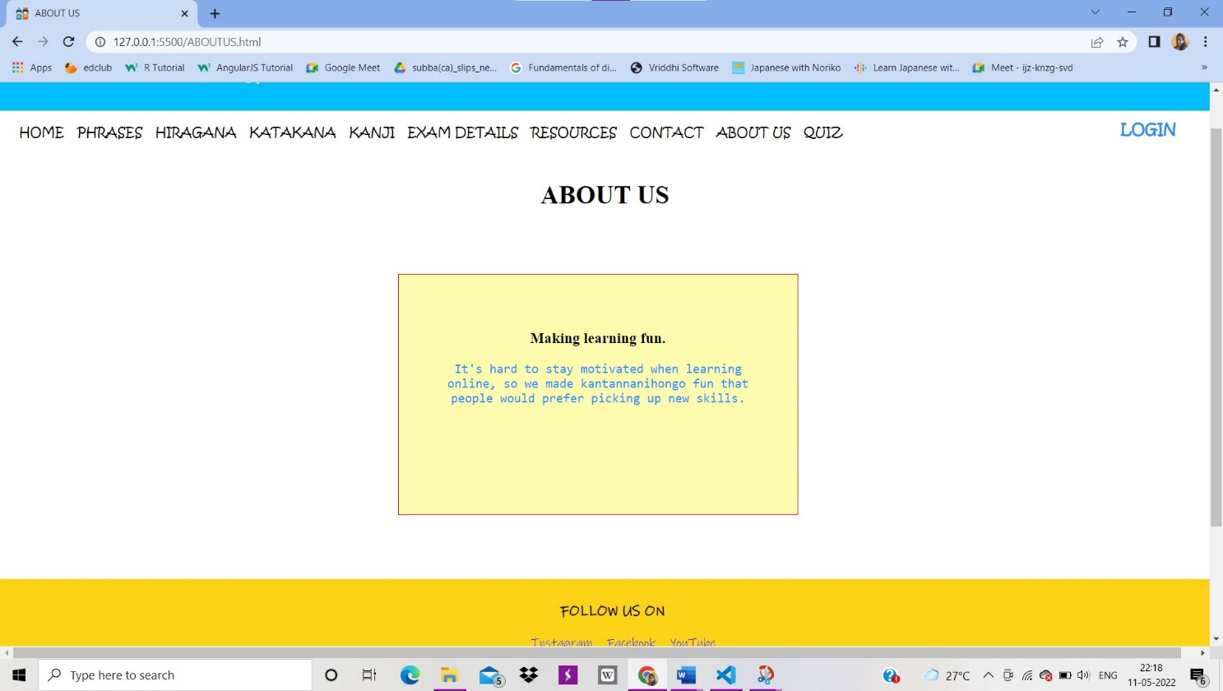

Quiz

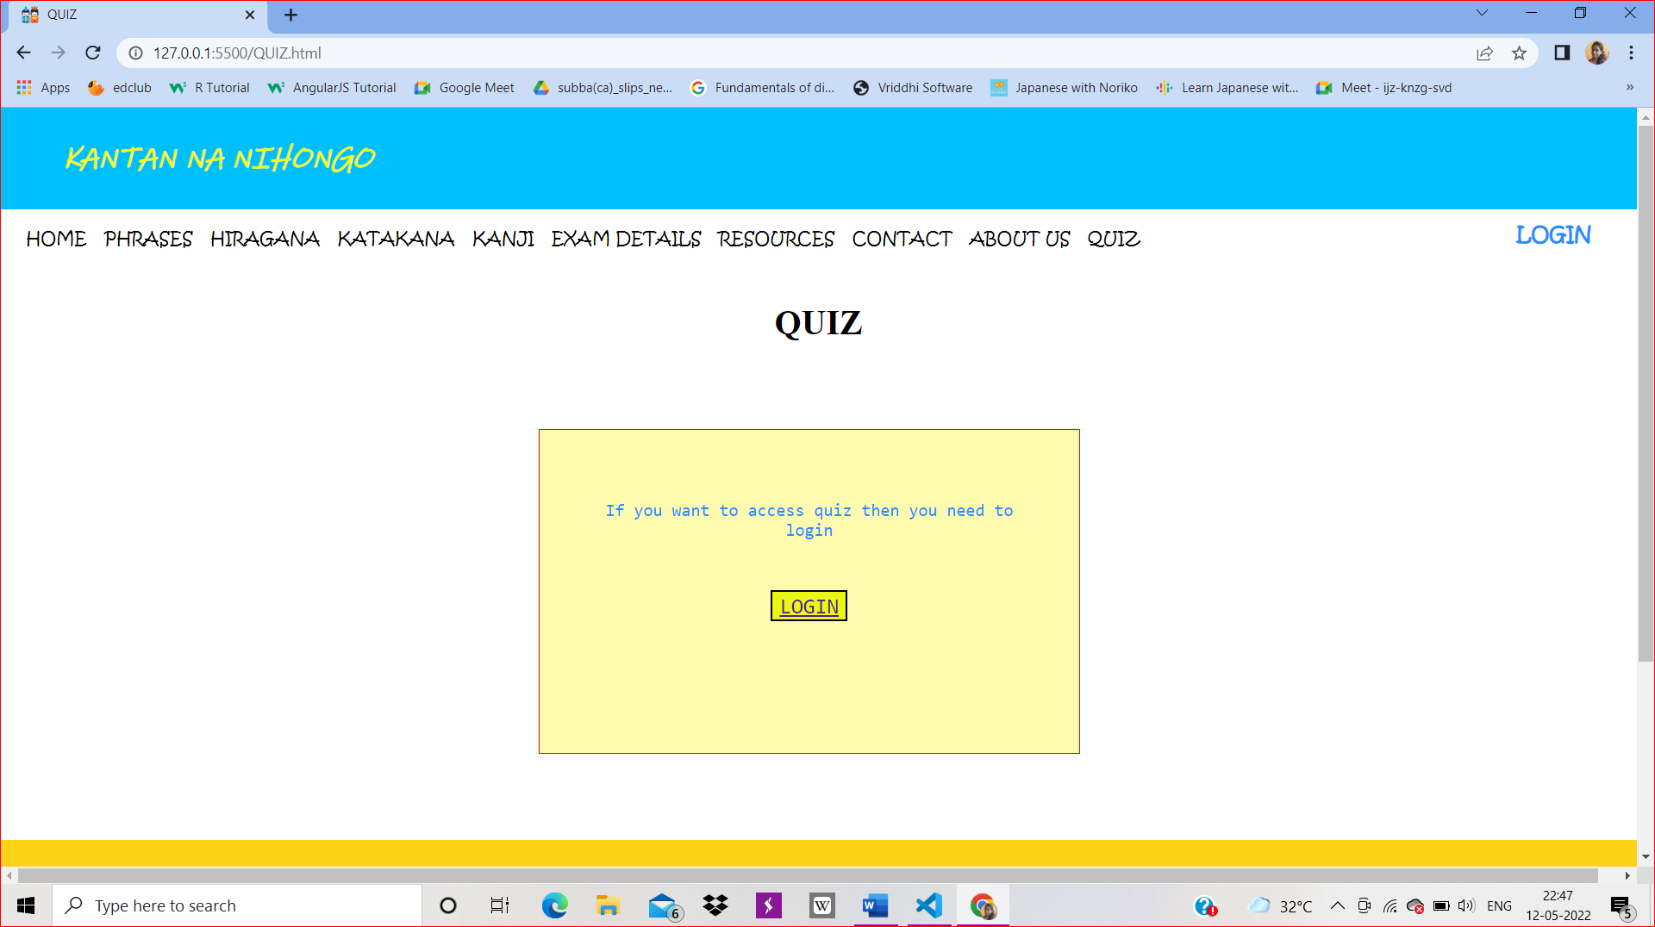

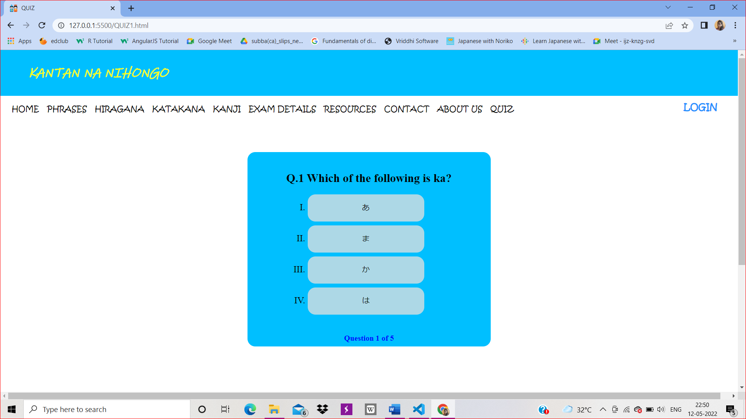

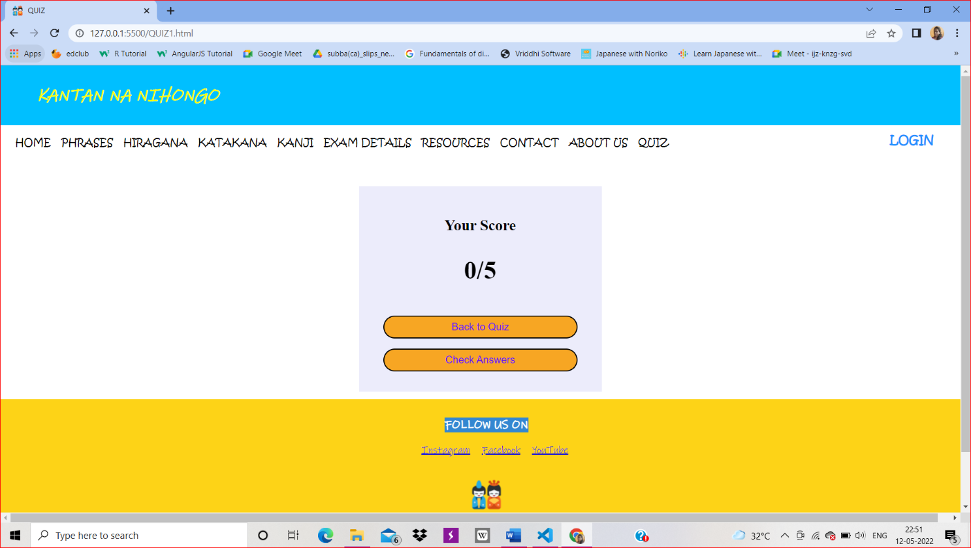

Login Page

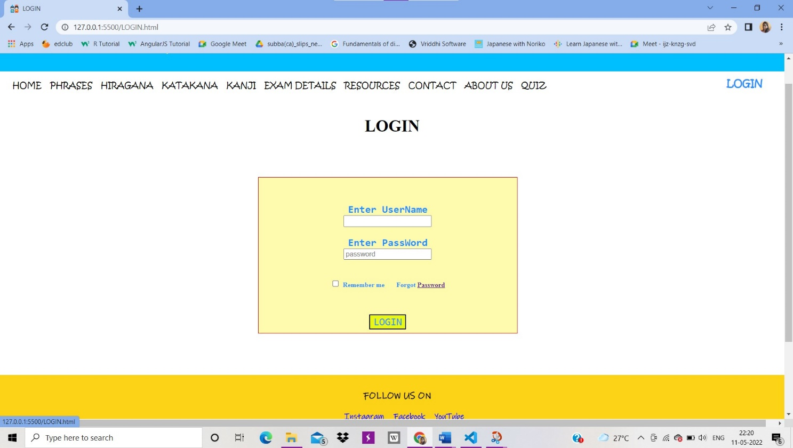

**Limitations**

Learning a new language online maybe challenging for the beginners.

Interactive classes are needed for any new language learning where it becomes easy.

**Bibliography**

1. [**https://www.w3schools.com/**](https://www.w3schools.com/)
2. [**https://smilenihongo.teachable.com/**](https://smilenihongo.teachable.com/)
3. [**https://nihongo-e-na.com/eng/site/id345.html#group=nogroup&photo=7**](https://nihongo-e-na.com/eng/site/id345.html#group=nogroup&photo=7)
4. [**https://youtu.be/2jwdyO_UunE**](https://youtu.be/2jwdyO_UunE)